Smart Farmer-IOT Enabled Smart Farming Application

**CREATE NODE RED**

|  |  |
| --- | --- |
| TITLE | Smart Farmer-IOT Enabled Smart Farming  Application |
| DOMAIN NAME | INTERNET OF THINGS |
| TEAM ID | PNT2022TMID19661 |
| LEADER NAME | BHOOPESH R K |
| TEAM  MEMBERS  NAME | AMITKUMAR SHARMA R  GAUTAM KUMAR RAI D  KAMALI K |

**STEP 1:-**

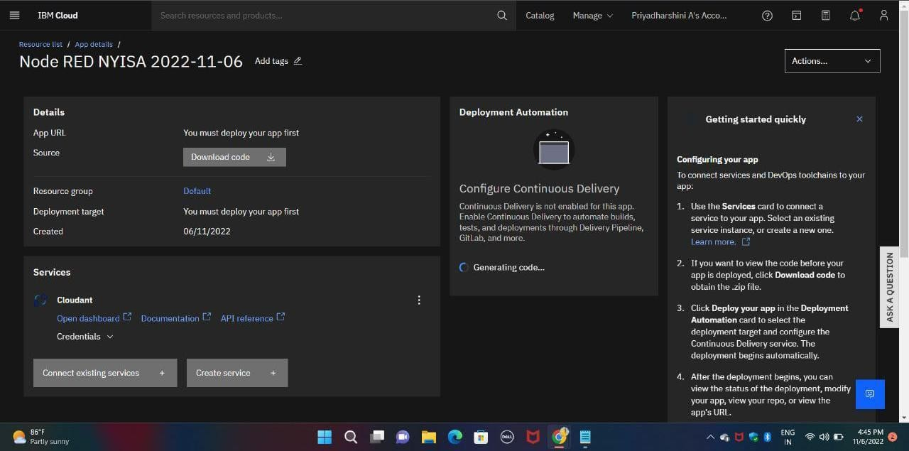

**STEP 2:-**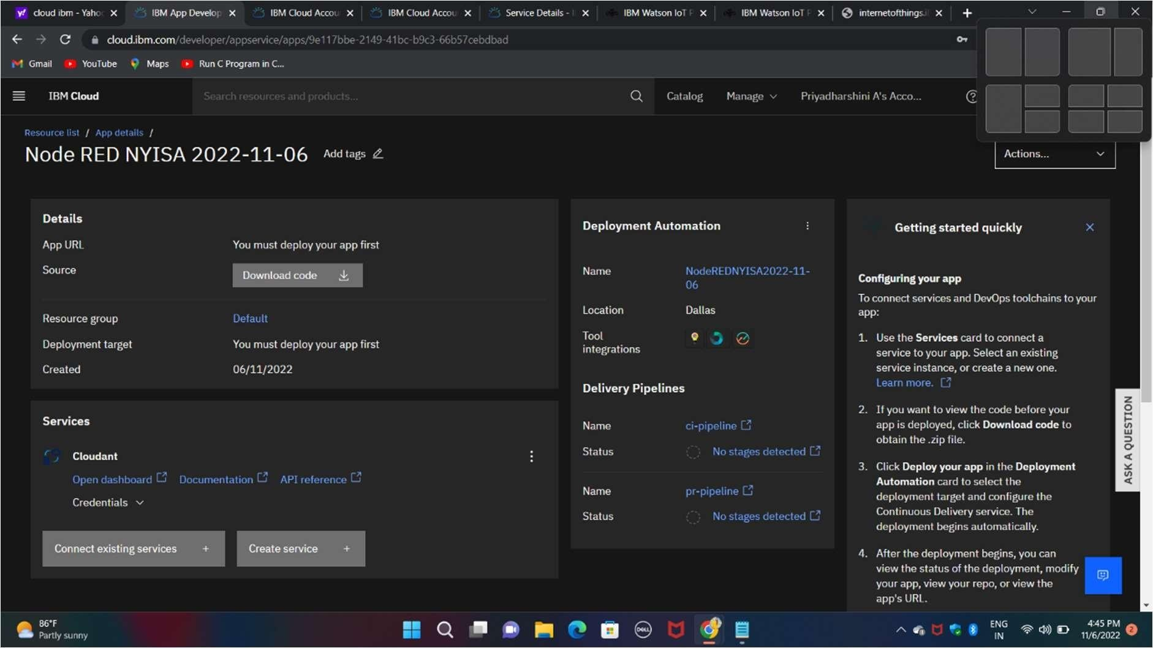

**STEP 3:-**

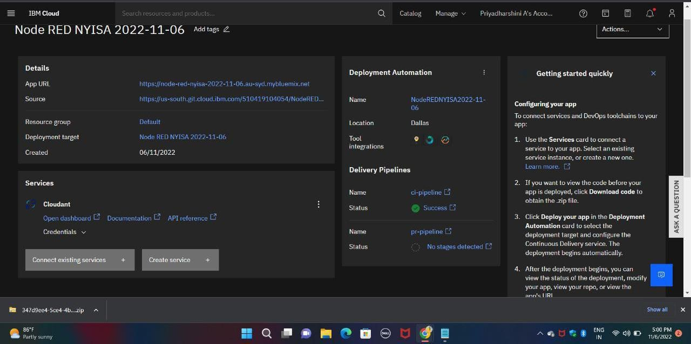

**STEP 4:-**

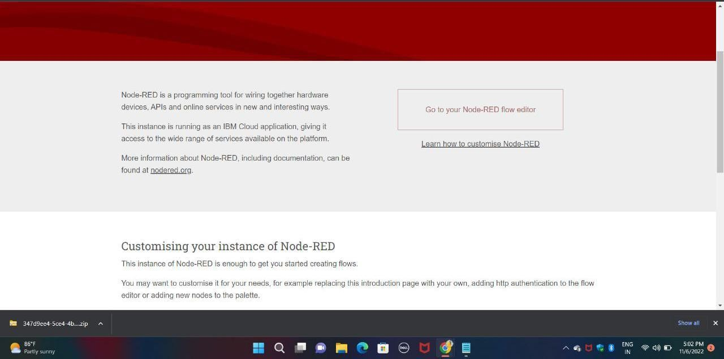

**STEP 5:-**

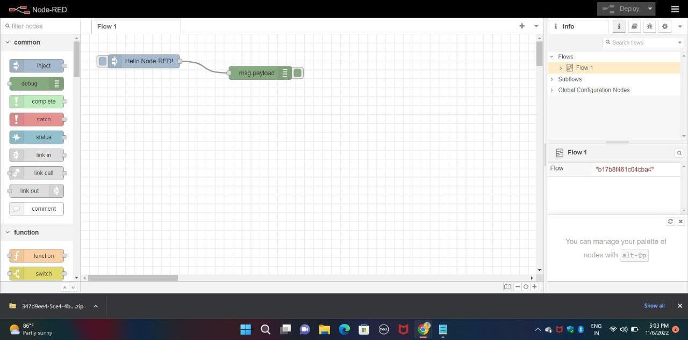

**STEP 6:-**

